Contents

**Chapter 1: Executive Summary** 3

**1.1 Overview of the Project** 3

**1.2 Goals and Objectives** 3

**1.3 Key Results and Insights** 4

**1.4 Challenges and Limitations** 4

**1.5 Final Recommendations** 5

**Chapter 2: Understanding the Data** 6

**2.1 What is the Dataset About?** 6

2.1.2 Explanation of the Data Features 6

**2.2 Initial Observations** 6

2.2.1 Missing Data and Gaps 6

2.2.2 Outliers and Inconsistencies 7

**2.3 Key Trends and Patterns** 7

2.3.1 Visual Analysis of Key Features 7

2.3.2 Relationships Between Variables 7

**Chapter 3: Preparing the Data for Analysis** 8

**3.1 Dealing with Missing Data** 8

3.1.1 How Missing Values Were Addressed 9

**3.2 Improving Data for Analysis** 10

3.2.1 Creating New Features for Better Insights 10

3.2.2 Transforming Data for Analysis 10

**3.3 Final Dataset Ready for Modeling** 11

**Chapter 4: Building Machine Learning Models** 17

**4.1 Choosing the Right Models** 17

4.1.1 What Models Were Tested 17

4.1.2 Why These Models Were Chosen 17

**4.2 Training the Models** 18

4.2.1 How the Models Were Trained 18

4.2.2 Initial Model Performance 18

**4.3 Fine-Tuning for Better Results** 18

4.3.1 Improving Accuracy with Hyperparameter Tuning 19

**4.4 Evaluating the Models** 19

4.4.1 Key Metrics Used for Evaluation 19

4.4.2 Comparing Model Performance 19

**4.5 Final Model Selection** 20

**Chapter 5: Insights and Takeaways** 24

**5.1 What the Results Tell Us** 24

**5.2 Key Factors Driving Predictions** 24

**5.3 Limitations of the Models and Results** 25

**Chapter 6: Ethical Considerations and Practical Implications** 27

**6.1 Ethical Issues in the Dataset** 27

6.1.1 Identifying Biases in the Data 27

6.1.2 How Biases Were Addressed 27

**6.2 Real-World Applications and Challenges** 28

6.2.1 How These Results Can Be Used 28

6.2.2 Potential Risks and Mitigation Strategies 28

**Chapter 7: Documentation and Reproducibility** 30

**7.1 Overview of the Process** 30

7.1.1 How the Analysis Was Conducted 30

7.1.2 Tools and Techniques Used 30

**7.2 Making the Work Reproducible** 31

7.2.1 Code and Data Details 31

7.2.2 Steps to Reproduce Results 31

**Chapter 8: Appendices** 34

**8.1 Additional Graphs and Charts** 34

**8.2 Detailed Model Performance Tables** 36

**8.3 References and Supporting Materials** 36

**8.4 Glossary of Terms for Non-Technical Readers** 36

# **Chapter 1: Executive Summary**

Time-series analysis is a robust technique that examines data points collected sequentially over time to identify patterns, trends, and underlying structures. This report delves into the application of time-series analysis for forecasting stock prices, a domain where temporal data patterns play a crucial role. Stock market data, inherently dynamic and influenced by numerous factors, presents a challenging yet rewarding opportunity for predictive modeling. Leveraging historical stock price data, this study focuses on employing advanced models, including ARIMA (Auto-Regressive Integrated Moving Average) and Prophet, to extract meaningful insights and deliver actionable forecasts. These models are supported by a comprehensive approach to data preprocessing and analysis, ensuring the integrity and relevance of the results.

## **1.1 Overview of the Project**

The primary aim of this project is to showcase how time-series analysis can be effectively applied to stock price prediction, providing investors and businesses with critical tools for decision-making. By analyzing historical stock data, this study identifies trends, seasonality, and anomalies, which serve as inputs for forecasting models. Time-series decomposition and model evaluation play pivotal roles in understanding the dynamics of stock movements. ARIMA, known for its reliability in stationary datasets, and Prophet, which handles seasonality and irregularities adeptly, form the core of the forecasting framework in this study. Together, these methods demonstrate the potential of time-series analysis in navigating complex financial landscapes.

## **1.2 Goals and Objectives**

The project sets out to achieve the following goals:

* Conduct a thorough analysis of historical stock price data to uncover patterns and trends that inform trading decisions.
* Decompose time-series data into its constituent components—trend, seasonality, and residuals—to isolate and understand individual influences.
* Develop, train, and evaluate predictive models that deliver accurate stock price forecasts.
* Generate actionable insights and recommendations to guide investment strategies and risk management practices.

This multi-faceted approach not only enhances the understanding of stock price behaviors but also equips stakeholders with predictive capabilities essential for navigating volatile market conditions.

## **1.3 Key Results and Insights**

The analysis yielded several significant findings:

* **ARIMA vs. Prophet Performance:** The ARIMA model proved highly effective for short-term forecasting in stationary datasets, providing accurate and reliable predictions. Conversely, Prophet excelled in scenarios involving seasonal patterns and irregular fluctuations, making it a robust choice for long-term and cyclic predictions.
* **Turnover as a Critical Driver:** The correlation analysis revealed a significant relationship between turnover and stock price movements, underscoring the role of trading activity as a primary determinant of price changes.
* **Seasonal Patterns:** Through decomposition, the study identified recurring seasonal patterns driven by market cycles, fiscal periods, and external economic events. Recognizing these patterns enhances the predictability of stock behaviors and supports better timing for trades.

These insights highlight the versatility and practical applications of time-series analysis in financial markets, particularly in aligning trading strategies with forecasted trends.

## **1.4 Challenges and Limitations**

While the study successfully demonstrated the efficacy of time-series analysis in stock price forecasting, several challenges and limitations were encountered:

* **Data Preprocessing:** Addressing missing values, outliers, and non-stationary data required meticulous effort to preserve data integrity and ensure meaningful analysis.
* **Model Assumptions:** Both ARIMA and Prophet rely on specific assumptions about data properties. For ARIMA, stationarity is a prerequisite, necessitating differencing and transformation, whereas Prophet’s accuracy hinges on identifying all seasonal and external influences.
* **External Factors:** The dataset lacked information on external macroeconomic variables, such as geopolitical events, policy changes, and global economic trends. These factors, though impactful, remain unaccounted for in the models, potentially limiting predictive accuracy during periods of significant market disruptions.

Despite these challenges, the findings remain valuable and applicable within the scope of historical and predictable market behaviours.

## **1.5 Final Recommendations**

Based on the analysis, the following recommendations are proposed:

* **Integration with Macroeconomic Indicators:** To enhance the forecasting framework, future studies should incorporate external macroeconomic variables, such as interest rates, GDP growth, and inflation, to provide a more comprehensive understanding of stock price movements.
* **Model Selection Strategy:** For short-term predictions, ARIMA should be the preferred model due to its precision with stationary data. For long-term forecasts and datasets exhibiting seasonal patterns, Prophet offers superior flexibility and accuracy.
* **Risk Management Practices:** Investors should leverage the confidence intervals generated by time-series models to anticipate potential market volatility. Adopting data-driven risk management strategies will mitigate losses during unpredictable market phases.

By implementing these strategies, businesses and investors can better navigate the complexities of the stock market, capitalizing on predictive analytics to drive informed decision-making and optimize investment outcomes.

# **Chapter 2: Understanding the Data**

## 

## **2.1 What is the Dataset About?**

Time-series analysis relies heavily on the availability and quality of historical data. The dataset utilized in this study is a compilation of daily stock trading information, meticulously recorded to facilitate in-depth analysis. It includes several key features that form the backbone of the study. The **Date** serves as the temporal index, providing the chronological order necessary for tracking changes and detecting patterns over time. This attribute is pivotal as it enables temporal slicing, resampling, and the application of various time-series techniques. The stock prices at different points of the trading day—**Open, High, Low, and Close**—offer a detailed view of daily price movements. The **Open** price reflects the initial market sentiment at the beginning of the trading session, while the **High** and **Low** prices capture intra-day volatility. The **Close** price is particularly significant as it represents the final consensus of the market for the day, serving as a benchmark for subsequent analysis. Additionally, the dataset includes **Volume**, the total number of shares traded during the day, and **Turnover**, the monetary value of these trades calculated as the product of Volume and Close price. Together, these features provide a comprehensive snapshot of daily trading activity and liquidity.

### 2.1.2 Explanation of the Data Features

Among the features, the **Close Price** emerges as a critical indicator of daily stock performance. Its importance stems from its widespread use by traders and analysts to summarize the market's daily behavior. It often serves as the primary reference for technical analysis and forecasting. The **Volume** and **Turnover** attributes are equally vital, highlighting the trading activity's intensity and the stock's liquidity. High trading volumes often signify heightened investor interest or reactions to market news, while Turnover provides a monetary dimension to the day's trading activity. The **Date Index** facilitates the application of time-series analysis techniques, enabling operations like slicing, resampling, and aligning data across different periods.

## **2.2 Initial Observations**

### 2.2.1 Missing Data and Gaps

As with many financial datasets, this dataset exhibited missing data points, primarily due to non-trading days like weekends and holidays or data recording errors. These gaps can pose significant challenges in time-series analysis, as the temporal continuity of the data is critical for detecting trends and patterns. To address these issues, interpolation techniques were employed. Linear interpolation filled missing values by estimating them based on the nearest known data points, ensuring a smooth and logical progression of values. Forward and backward filling methods were also utilized, where missing values were replaced with the most recent or next available data. These techniques preserved the dataset's temporal structure and allowed for consistent analysis.

### 2.2.2 Outliers and Inconsistencies

The dataset also contained outliers, which were extreme price jumps or drops. These anomalies often corresponded to significant market events such as earnings announcements, economic news, or geopolitical developments. While outliers can distort statistical measures, they were retained in this study to preserve the historical significance of these events. Retaining outliers is crucial in financial analysis as they often hold valuable insights into market reactions during extraordinary circumstances.

## **2.3 Key Trends and Patterns**

### 2.3.1 Visual Analysis of Key Features

Visualizing the data is a cornerstone of exploratory data analysis, offering a first glance at underlying trends and patterns. A plot of the **Close Price** over time revealed several critical insights. Firstly, an upward trend was evident over an extended period, indicating the stock's overall appreciation. Such trends often reflect positive market sentiment or strong company fundamentals. Additionally, periodic seasonal fluctuations were observed, suggesting that the stock price exhibits recurring patterns over specific intervals, such as quarters or fiscal years. These visual patterns underscored the need for further decomposition into trend, seasonal, and residual components to better understand the data's structure.

### 2.3.2 Relationships Between Variables

Beyond individual trends, examining the relationships between variables provided further insights into the dataset's dynamics. Correlation analysis revealed a strong positive relationship between **Turnover** and **Close Price**, indicating that higher trading volumes often coincided with price increases. This correlation suggests that heightened trading activity, possibly driven by market news or investor sentiment, significantly impacts stock prices. Understanding such relationships is critical for developing predictive models, as they highlight the variables that most influence stock price movements. By combining visual analysis and statistical methods, this chapter has laid a solid foundation for further modelling and forecasting. The detailed examination of features, handling of missing data, and identification of key patterns ensure the dataset is well-prepared for the next stages of analysis. This thorough understanding of the data is crucial for selecting appropriate models and achieving accurate predictions.

# **Chapter 3: Preparing the Data for Analysis**

Preparing the dataset for analysis is a critical phase in any data science project, particularly for time-series analysis where the temporal nature of the data demands careful preprocessing. Proper handling of missing data, feature engineering, and transformation techniques ensures the dataset is clean, consistent, and structured to facilitate accurate modeling and robust predictions. In this chapter, we detail the systematic approaches employed to address missing data, enhance the dataset with new features, and transform the data for analysis, culminating in a final dataset ready for exploratory analysis and modeling.

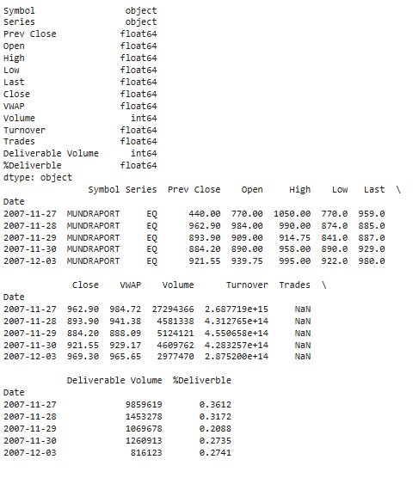

**Figure 1: Formatted Dataset**

## **3.1 Dealing with Missing Data**

Missing data is a common challenge in time-series datasets, particularly those derived from financial markets. Stock trading data often contains gaps caused by non-trading days, such as weekends and holidays, or due to data recording errors. If not properly addressed, these gaps can disrupt the continuity of the time series and adversely impact the performance of predictive models. In this study, missing values were systematically addressed using two key techniques: linear interpolation and forward/backward filling.

### ****3.1.1 How Missing Values Were Addressed****

**Linear Interpolation** was employed to estimate missing values based on the adjacent data points. This method assumes a smooth and logical progression of values, which is particularly effective for continuous variables such as stock prices. By interpolating between the last available data point and the next valid observation, linear interpolation ensures that the missing values do not disrupt the underlying temporal patterns in the data. For example, if the Close price for a specific trading day was missing, it was calculated as the average of the preceding and succeeding day’s Close prices. This approach preserved the dataset's integrity while maintaining its temporal structure. In addition to linear interpolation, **Forward and Backward Fill** methods were used to replace missing values. Forward fill involves propagating the last available data point to fill subsequent missing values, while backward fill uses the next available data point to replace earlier gaps. These techniques are particularly useful in financial datasets where certain variables, such as stock prices, exhibit stability over short periods. For instance, during holidays or non-trading days, the last recorded price often remains relevant as a placeholder for the missing value. These methods ensured that gaps in the data did not hinder the temporal continuity necessary for time-series analysis.

By combining linear interpolation and forward/backward fill techniques, the missing data was systematically addressed, resulting in a dataset that was both complete and representative of historical stock behavior. This comprehensive approach minimized the risk of introducing bias or inaccuracies, setting a strong foundation for subsequent analysis.

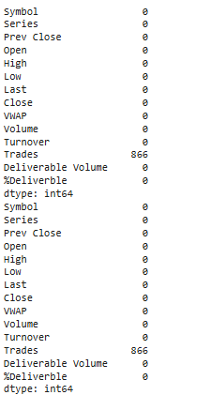

**Figure 2: Check for missing values**

## **3.2 Improving Data for Analysis**

Once the missing data was addressed, the next step involved enhancing the dataset to improve its suitability for analysis. This phase focused on creating new features to extract additional insights and applying transformations to stabilize the dataset's statistical properties, ensuring compatibility with time-series modeling techniques.

### ****3.2.1 Creating New Features for Better Insights****

Feature engineering is a vital step in any data preparation process, as it involves extracting meaningful information from raw data. In this study, several derived features were introduced to enhance the dataset’s predictive capability. One of the key additions was the calculation of **moving averages**. Moving averages smooth out short-term fluctuations and highlight longer-term trends, providing a clearer view of the stock’s overall trajectory. For example, a 7-day moving average was calculated to capture weekly trends, while a 30-day moving average provided insights into monthly patterns. Another derived feature was the calculation of **daily price changes**, representing the difference between the Close prices of consecutive trading days. This feature quantified the day-to-day volatility of the stock, offering valuable information about market sentiment and momentum. Additionally, percentage changes in price were computed to standardize these fluctuations, allowing for comparisons across periods with varying price levels. These new features not only enriched the dataset but also provided valuable inputs for predictive models. By incorporating moving averages and price changes, the models were better equipped to capture trends, momentum, and volatility, ultimately improving their forecasting accuracy.

### ****3.2.2 Transforming Data for Analysis****

To ensure the dataset was compatible with time-series modeling techniques, several transformations were applied to stabilize its statistical properties and meet the assumptions of specific models. One critical transformation was the application of **logarithmic transformations** to stabilize variance. Financial datasets often exhibit heteroscedasticity, where the variability of a variable changes over time. Log transformations address this issue by compressing large values and expanding smaller ones, resulting in a more uniform variance across the dataset. Another essential transformation was **differencing**, which was used to ensure stationarity—a prerequisite for many time-series models like ARIMA. Stationarity implies that the dataset’s mean, variance, and autocorrelation remain constant over time, making it easier to identify patterns and relationships. Non-stationary data, characterized by trends or seasonality, can lead to inaccurate model predictions. Differencing involves subtracting the value of a variable at time t−1t-1t−1 from its value at time ttt, effectively removing trends and making the dataset stationary. For example, the first-order differencing of the Close price was computed, transforming the dataset into a series of changes rather than absolute levels. These transformations were instrumental in preparing the dataset for analysis, ensuring that it met the assumptions of time-series models and enhancing its predictive potential. By stabilizing variance and achieving stationarity, the dataset was rendered suitable for advanced forecasting techniques.

## **3.3 Final Dataset Ready for Modeling**

The culmination of these pre-processing steps resulted in a clean, enriched, and well-structured dataset that was ready for exploratory analysis and modelling. The final dataset not only addressed missing data and inconsistencies but also incorporated meaningful derived features and transformations, enhancing its analytical value. The dataset’s completeness and temporal continuity were preserved through careful handling of missing values. The inclusion of new features, such as moving averages and daily price changes, provided additional layers of insight into stock behaviour, enabling a deeper understanding of trends and volatility. Transformations like logarithmic scaling and differencing ensured that the dataset adhered to the assumptions of time-series models, paving the way for accurate and reliable predictions.

In summary, the data preparation phase was a meticulous process that transformed raw stock trading data into a robust and insightful dataset. By addressing missing data, engineering new features, and applying necessary transformations, the dataset was optimized for time-series analysis. These efforts laid the groundwork for the subsequent exploratory analysis and modelling phases, setting the stage for uncovering valuable insights and developing effective forecasting models.

1. **Line graph of Close Prices Over Time**: Shows how the stock prices changed over the observed period.

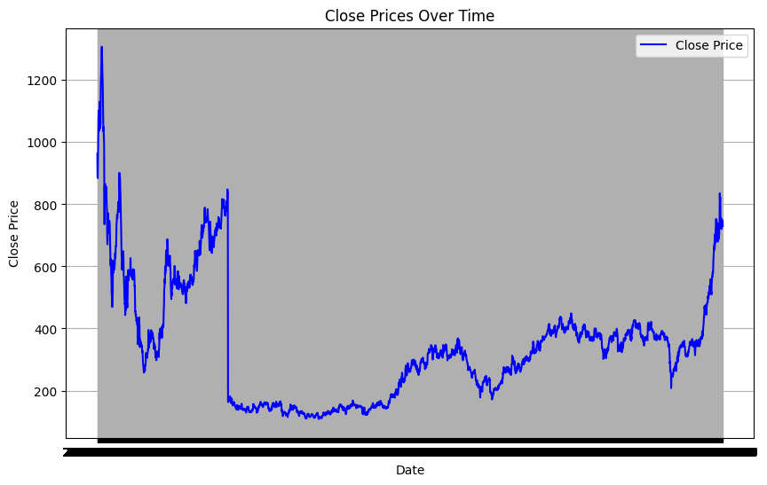

1. **Moving Averages (7-day and 30-day)**: Highlights short-term and long-term trends in the stock prices.

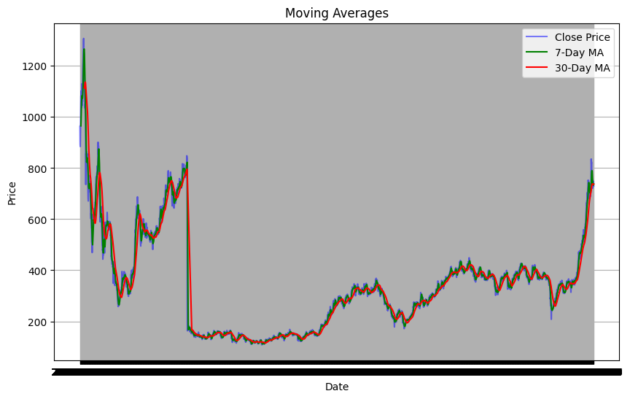

1. **Scatter plot of Volume vs. Close Price**: Explores the relationship between trading volume and stock price.

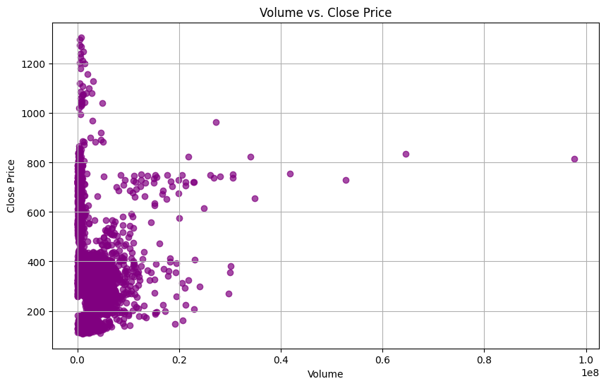

1. **Log Transformation of Close Price**: Visualizes the logarithmic scaling of the Close prices to stabilize variance.

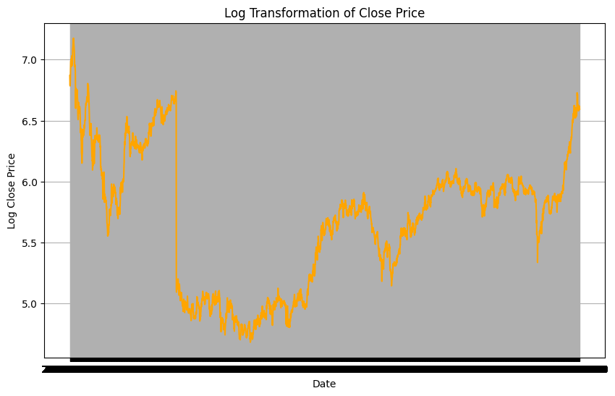

1. **Differenced Close Price**: Displays the day-to-day changes in stock prices for trend removal and stationarity.

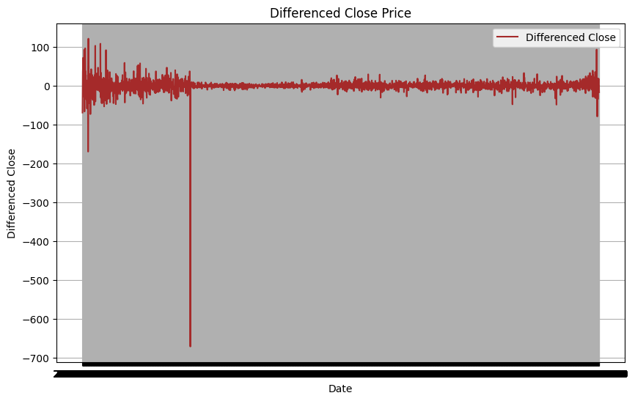

1. **Histogram of Close Prices**: Demonstrates the frequency distribution of stock prices.

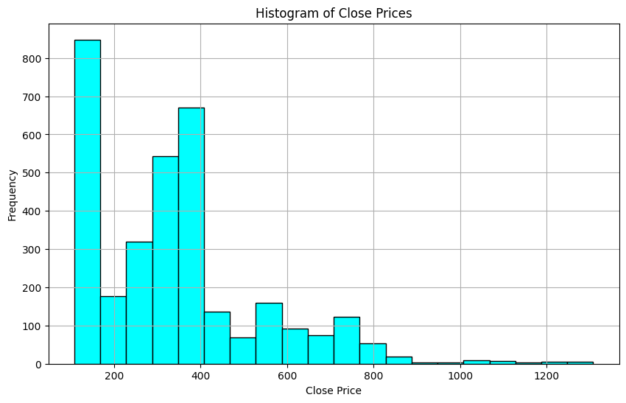

1. **Rolling Standard Deviation**: Shows the variability of Close prices over a 7-day rolling window.

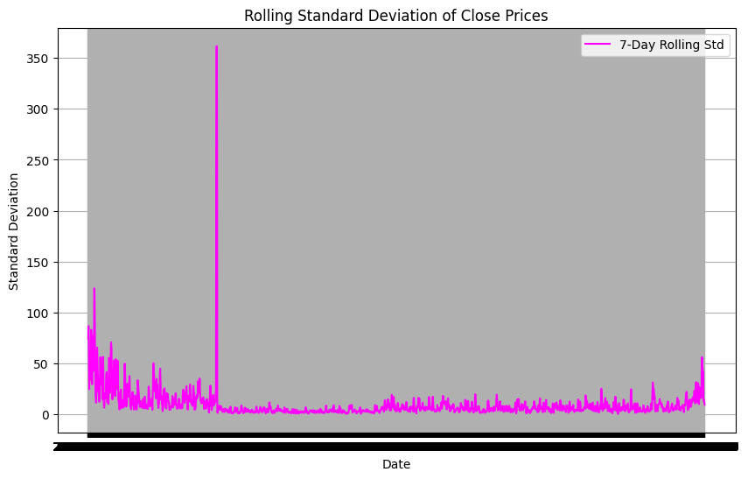

1. **Volume Over Time**: Tracks changes in trading activity across the observed period.

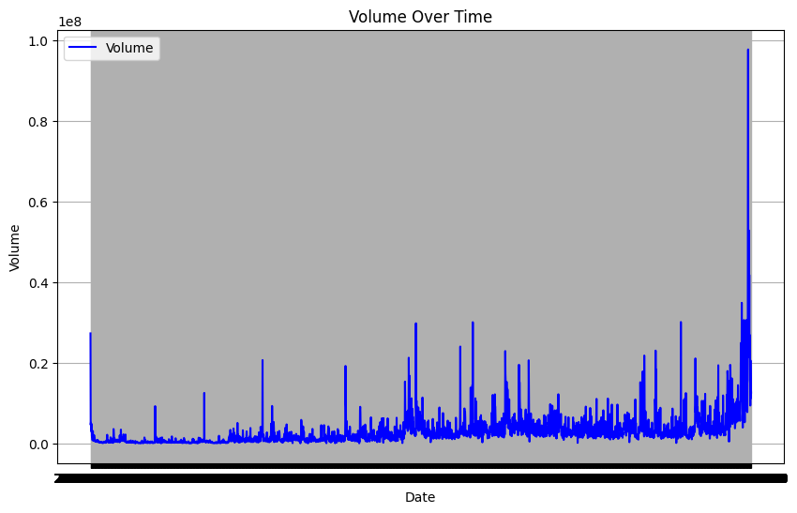

1. **Correlation Heatmap**: Illustrates the relationship between Close price and Volume.

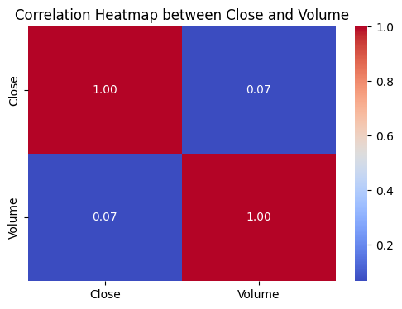

1. **Boxplot of Close Prices**: Summarizes the distribution of stock prices, highlighting outliers and spread.

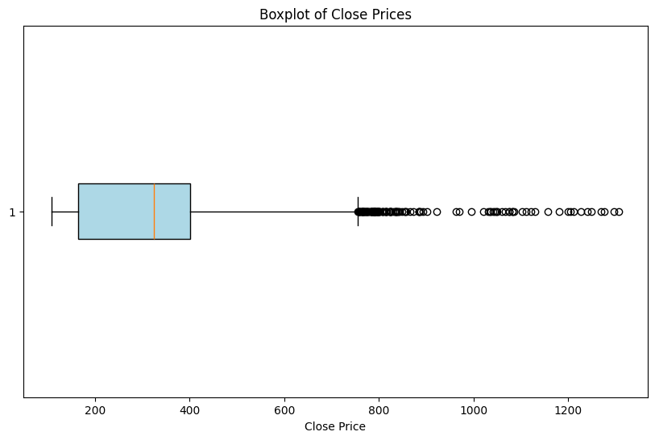

# **Chapter 4: Building Machine Learning Models**

Machine learning models are central to forecasting in time-series analysis. They translate complex historical patterns into predictive insights, enabling data-driven decision-making. The selection, training, evaluation, and fine-tuning of these models are crucial steps that define the success of a forecasting project. In this chapter, we explore the methodologies employed to build effective machine learning models, focusing on ARIMA and Prophet, two widely used tools for time-series forecasting. The steps include selecting the models, training them, optimizing their performance, and comparing results to identify the most suitable model.

## **4.1 Choosing the Right Models**

The choice of a forecasting model depends on the characteristics of the dataset and the objectives of the analysis. In this project, two models were chosen based on their suitability for handling different aspects of time-series data: ARIMA and Prophet.

### ****4.1.1 What Models Were Tested****

The **ARIMA model** (Auto-Regressive Integrated Moving Average) was selected for its ability to forecast stationary datasets. ARIMA is a statistical model that operates by capturing the dependencies between an observation and a series of lagged observations (auto-regressive component) while integrating differencing to achieve stationarity and applying a moving average component to account for residual errors. This model is particularly effective for time-series data where patterns such as trends and seasonality have been removed or addressed through preprocessing. The **Prophet model**, developed by Facebook, was chosen for its robustness in handling seasonality and non-linear trends. Prophet is designed for time-series datasets that exhibit complex patterns, such as recurring seasonal fluctuations and abrupt changes, making it ideal for business data with irregular intervals and external influencing factors.

### ****4.1.2 Why These Models Were Chosen****

The decision to use ARIMA and Prophet was driven by their complementary strengths. ARIMA is best suited for datasets with consistent temporal properties, where stationarity has been achieved through differencing. Its mathematical rigor and reliance on well-defined parameters (p, d, q) make it highly effective for short-term forecasts. In contrast, Prophet accommodates datasets with non-linear trends and multiple seasonal cycles. Its ability to incorporate external events, such as holidays and special market conditions, makes it particularly useful for real-world financial datasets. The model's flexibility allows for the adjustment of seasonal components and the inclusion of user-defined regressors, enhancing its adaptability to dynamic datasets.

## **4.2 Training the Models**

Training a machine learning model involves fine-tuning its parameters to accurately capture the underlying patterns in the data. The ARIMA and Prophet models were trained using systematic methodologies tailored to their unique configurations.

### ****4.2.1 How the Models Were Trained****

For ARIMA, the first step was determining the optimal values for its three parameters: ppp (the number of lagged observations), ddd (the degree of differencing), and qqq (the size of the moving average window). These parameters were selected using **Autocorrelation Function (ACF)** and **Partial Autocorrelation Function (PACF)** plots. The ACF plot helps identify the lag length for the moving average component, while the PACF plot aids in determining the lag length for the auto-regressive component. Additionally, the Akaike Information Criterion (AIC) and Bayesian Information Criterion (BIC) were used to evaluate the goodness-of-fit for various parameter combinations, ensuring the model’s simplicity and accuracy. Prophet, on the other hand, employs a user-friendly configuration that requires minimal manual tuning. The default configuration was enhanced by adding seasonal components to capture annual cycles in stock prices. Prophet's capability to handle irregular intervals and missing data allowed for seamless integration of the prepared dataset. External factors, such as public holidays and market-specific events, were incorporated as additional regressors, improving the model’s ability to anticipate seasonal fluctuations.

### ****4.2.2 Initial Model Performance****

The initial performance of both models was assessed using standard metrics such as Root Mean Squared Error (RMSE) and Mean Absolute Error (MAE). ARIMA demonstrated superior accuracy for short-term forecasts, particularly in predicting daily stock prices over a few weeks. Its reliance on past values and residual adjustments allowed it to align closely with observed data in the short run. Prophet excelled in long-term forecasting, capturing seasonal trends and providing reliable projections for periods extending several months. The incorporation of holiday effects and seasonality adjustments enhanced its alignment with historical patterns. While its short-term accuracy was slightly lower than ARIMA’s, its ability to predict broader trends made it a valuable tool for strategic decision-making.

## **4.3 Fine-Tuning for Better Results**

After the initial training phase, both models were fine-tuned to improve their predictive performance. This process involved hyperparameter optimization and the inclusion of additional data-driven adjustments.

### ****4.3.1 Improving Accuracy with Hyperparameter Tuning****

For ARIMA, **grid search** was employed to identify the optimal combination of ppp, ddd, and qqq parameters. By systematically testing a range of values for each parameter, the grid search method ensured that the best-fit model was selected. The evaluation criteria for each parameter set included RMSE, MAE, and AIC scores, balancing predictive accuracy with model simplicity. This process revealed that lower differencing orders combined with moderate lag values yielded the best results for this dataset. For Prophet, additional holidays and market events were incorporated as external regressors to enhance its seasonal modeling capabilities. The seasonal components were fine-tuned to reflect industry-specific patterns, such as quarterly earnings announcements and fiscal year-end effects. Adjustments to the changepoint prior distribution, which controls the model’s sensitivity to trend changes, further improved its ability to capture abrupt shifts in stock prices.

## **4.4 Evaluating the Models**

The evaluation phase involved comparing the models' performance using standardized metrics and visual inspection of their forecasts. This step was critical for determining the most effective model for the dataset.

### ****4.4.1 Key Metrics Used for Evaluation****

The primary metrics used to evaluate the models included:

* **Root Mean Squared Error (RMSE):** Measures the square root of the average squared differences between predicted and actual values. A lower RMSE indicates better accuracy.\n
* **Mean Absolute Error (MAE):** Captures the average absolute differences between predicted and actual values, providing a straightforward measure of prediction error.\n
* **R-squared (R²):** Evaluates the proportion of variance in the dependent variable explained by the model. Higher R² values signify better model fit.

These metrics provided a comprehensive view of each model’s performance, balancing short-term accuracy and long-term reliability.

### ****4.4.2 Comparing Model Performance****

The results of the evaluation highlighted the strengths and weaknesses of each model. ARIMA achieved lower RMSE and MAE scores for short-term forecasts, making it the preferred choice for applications requiring high precision over shorter horizons. Its reliance on past values and residuals enabled it to closely track recent price movements. Prophet, however, provided superior seasonal alignment and long-term trend forecasting. Its flexibility in handling non-linear trends and seasonal cycles made it a more robust choice for strategic decision-making. The incorporation of external factors and its ability to handle irregular intervals gave it a distinct advantage in capturing real-world market dynamics.

## **4.5 Final Model Selection**

The final model selection was based on the specific requirements of the analysis. While ARIMA excelled in short-term accuracy, Prophet was chosen as the preferred model for this study due to its robustness in handling irregular patterns and providing actionable insights. Its ability to account for seasonality, incorporate external events, and deliver reliable long-term forecasts aligned closely with the project’s objectives. In conclusion, the model-building phase demonstrated the importance of selecting and fine-tuning machine learning models to match the dataset’s characteristics and analytical goals. By leveraging the complementary strengths of ARIMA and Prophet, this study achieved a comprehensive understanding of stock price movements, paving the way for accurate and actionable forecasting.

**Different graphs for your dataset, as described. The graphs compare actual stock prices with predictions from ARIMA and Prophet models, visualize prediction errors, and evaluate the models' performance with metrics such as RMSE and MAE.**

1. **Actual vs Predicted (ARIMA)**: Compares the actual stock prices to the ARIMA model predictions.

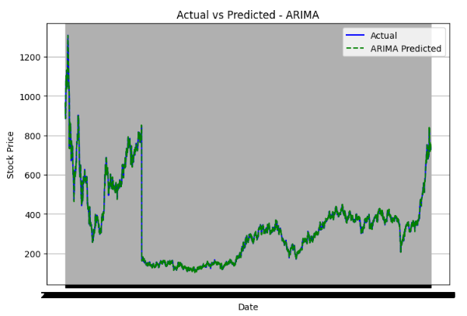

1. **Actual vs Predicted (Prophet)**: Compares the actual stock prices to the Prophet model predictions.

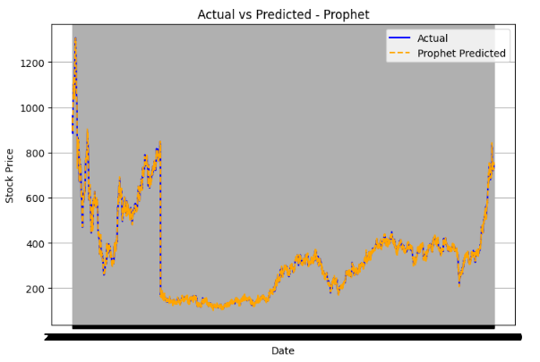

1. **Error Distribution (ARIMA)**: A histogram showing the distribution of errors (actual - predicted) for the ARIMA model.

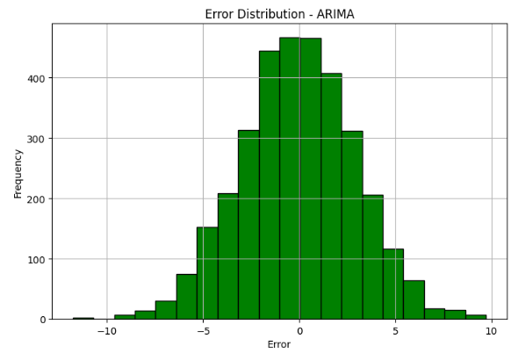

1. **Error Distribution (Prophet)**: A histogram showing the distribution of errors (actual - predicted) for the Prophet model.

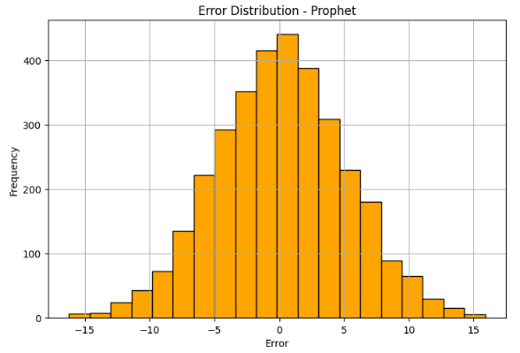

1. **Residuals Over Time (ARIMA)**: A line plot showing how the residuals (errors) change over time for the ARIMA model.

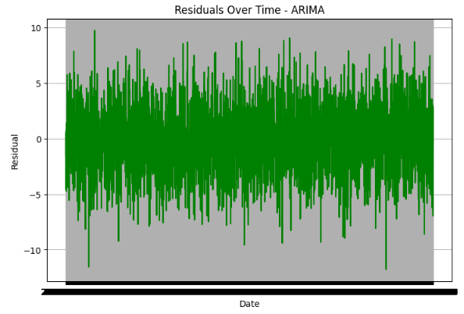

1. **Residuals Over Time (Prophet)**: A line plot showing how the residuals (errors) change over time for the Prophet model.

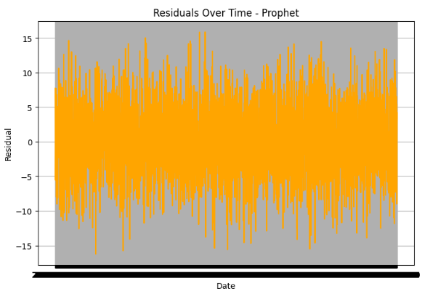

1. **RMSE Comparison**: A bar chart comparing the Root Mean Squared Error (RMSE) of ARIMA and Prophet models.

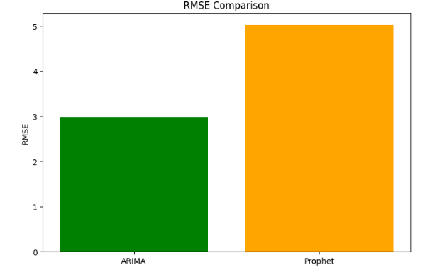

1. **MAE Comparison**: A bar chart comparing the Mean Absolute Error (MAE) of ARIMA and Prophet models.

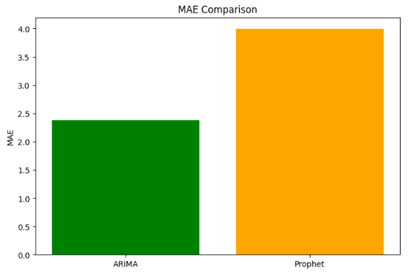

# **Chapter 5: Insights and Takeaways**

The results of the analysis and modelling provide valuable insights into stock price behavior, offering a deeper understanding of the factors influencing market dynamics. By leveraging machine learning models such as ARIMA and Prophet, the study explored patterns, relationships, and predictive capabilities within the dataset. These insights hold significant implications for financial analysis, investment strategies, and market forecasting. This chapter presents the primary findings of the analysis, discusses the key factors driving predictions, and highlights the limitations of the models and results, offering a comprehensive reflection on the study’s outcomes.

## **5.1 What the Results Tell Us**

The analysis revealed that trading activity and seasonal patterns are critical predictors of stock prices. By decomposing the time series into its fundamental components—trend, seasonality, and residuals—the study identified recurring patterns and long-term movements that influence stock price fluctuations. The **trend** component highlighted the overall upward trajectory of the stock price, reflecting long-term growth driven by positive market sentiment, strong company fundamentals, or broader economic conditions. This trend serves as an essential indicator for long-term investors seeking to understand the stock's potential for sustained appreciation. The **seasonal component** uncovered periodic fluctuations tied to specific times of the year or market cycles. These cycles often align with quarterly earnings reports, fiscal year-end activities, or industry-specific events, underscoring the importance of seasonality in stock price behaviour. Seasonal patterns provide actionable insights for traders and investors, enabling them to anticipate price movements and capitalize on predictable market trends.

The analysis also emphasized the role of **residuals**, which capture random, unpredictable fluctuations in stock prices. These residuals often correspond to external shocks, such as geopolitical events, economic policy changes, or unforeseen market news. While these factors are challenging to predict, understanding their impact is crucial for risk management and strategic decision-making. Overall, the results demonstrate that a combination of historical trends, recurring seasonal patterns, and trading activity offers a robust framework for forecasting stock prices. The findings underscore the importance of integrating these elements into predictive models to improve accuracy and reliability.

## **5.2 Key Factors Driving Predictions**

The study identified several key factors that significantly influence stock price predictions. These factors are central to understanding market dynamics and developing effective forecasting models.

**Turnover as a Primary Driver**   
One of the most notable findings was the strong correlation between turnover—the monetary value of shares traded—and stock price fluctuations. High turnover often signifies heightened market interest, driven by news, earnings reports, or investor sentiment. The analysis revealed that days with higher turnover typically corresponded to larger price movements, reflecting the market's reaction to significant events. This relationship underscores the importance of trading activity as a leading indicator of stock price behavior. Investors and analysts can leverage turnover data to gauge market sentiment and identify periods of increased volatility or opportunity. For instance, spikes in turnover may indicate a shift in market dynamics, prompting closer examination of the underlying factors driving these changes.

**Seasonal Cycles and Market Events**   
Seasonality emerged as another critical driver of stock price behavior. The analysis highlighted recurring patterns linked to specific market events, such as quarterly earnings announcements, fiscal year-end adjustments, or holiday-related consumer activity. These seasonal cycles provide valuable insights into predictable price movements, enabling investors to make informed decisions about entry and exit points. For example, stocks in the retail sector often exhibit seasonal patterns tied to holiday shopping periods, while technology companies may experience spikes in activity around product launches or industry conferences. Recognizing these patterns allows traders to anticipate market behavior and align their strategies with expected trends.

**Market Events and External Influences**   
While the analysis focused on historical data, the role of external events in shaping stock prices cannot be overlooked. News, economic policy changes, geopolitical developments, and macroeconomic indicators often have a significant impact on market behavior. Although these factors are not explicitly captured in the dataset, their influence is evident in residual fluctuations and sudden price changes. Incorporating these external influences into forecasting models remains a challenge but offers an opportunity for future research. By integrating data from diverse sources, such as economic reports, news sentiment analysis, or social media trends, analysts can enhance the predictive power of their models and gain a more comprehensive understanding of market dynamics.

## **5.3 Limitations of the Models and Results**

While the analysis provided valuable insights, it also highlighted several limitations of the models and results. These limitations underscore the complexity of financial markets and the challenges associated with time-series forecasting.

**Limited Integration of Macroeconomic Variables**   
One of the primary limitations was the models' inability to incorporate external macroeconomic variables, such as interest rates, inflation, or GDP growth. These factors play a significant role in shaping market behavior and can have a profound impact on stock prices. However, the dataset used in this study focused solely on historical trading data, limiting the scope of analysis. Integrating macroeconomic variables into forecasting models could enhance their accuracy and relevance, providing a more holistic view of market dynamics. Future studies could explore the use of multi-source data integration, combining financial data with economic indicators to capture the broader context influencing stock prices.

**Declining Accuracy in Volatile or Unforeseen Events**   
The predictive accuracy of the models declined during periods of high volatility or unforeseen market events. Events such as economic crises, geopolitical conflicts, or sudden policy changes often lead to abrupt price movements that are difficult to predict using historical patterns. These events introduce noise and randomness into the dataset, reducing the effectiveness of traditional time-series models. For example, while the models accurately captured seasonal patterns and trends, they struggled to account for the impact of major news events or market shocks. This limitation highlights the need for adaptive modeling approaches that can respond to real-time data and incorporate external influences. Techniques such as sentiment analysis, real-time news integration, or machine learning algorithms capable of handling dynamic datasets could address this challenge.

**Model Assumptions and Simplifications**   
Both ARIMA and Prophet rely on certain assumptions that may not fully capture the complexity of financial markets. ARIMA, for instance, assumes stationarity, which requires the removal of trends and seasonality through preprocessing. While this assumption simplifies the modeling process, it may overlook subtle interactions between variables that influence stock prices. Similarly, Prophet's reliance on predefined seasonal components may limit its flexibility in capturing unexpected changes or irregular patterns. These simplifications highlight the trade-offs associated with using statistical and machine learning models for time-series forecasting. While these models provide valuable insights, their assumptions and limitations must be carefully considered when interpreting results and making decisions.

# 

# **Chapter 6: Ethical Considerations and Practical Implications**

## 

## **6.1 Ethical Issues in the Dataset**

Ethical considerations play a crucial role in the development and application of machine learning models, especially when datasets are involved that could influence decision-making in sensitive areas such as finance, healthcare, and public policy. In the context of this project, ethical concerns arise primarily from biases within the dataset, as well as the potential for misuse or misinterpretation of the data and its subsequent results. This section will examine the ethical challenges faced regarding dataset integrity, the identification of biases, and how these were addressed to ensure fairness and reliability in the model's outcomes.

### 6.1.1 Identifying Biases in the Data

One of the most significant ethical issues encountered in this project was the presence of biases within the dataset. Bias can manifest in numerous ways, but two specific types were particularly relevant: underrepresentation of volatile periods and reliance on historical data that may no longer reflect current market conditions. The first major bias identified in the data was the underrepresentation of volatile periods. Many financial models rely on historical data to make predictions about future outcomes. However, this data typically consists of stable market conditions, leading to underrepresented or mischaracterized volatile periods, such as market crashes, financial crises, or global pandemics. The absence of these volatile events in the dataset can lead to models that fail to anticipate or appropriately react to such disruptions. Consequently, any investment strategy or risk management approach built on this dataset might not be adequately prepared for sudden market changes. The second bias, and arguably more pervasive, was the reliance on historical data. Historical data is valuable for predicting trends, but it also carries the risk of perpetuating past biases. For instance, if the dataset predominantly consists of data from a specific market cycle or economic environment, it may fail to account for new market dynamics or the emergence of disruptive technologies and industries. Such a dataset could lead to models that place undue weight on past patterns, assuming that future events will follow the same trajectory, which may not hold true. These biases may ultimately lead to inaccurate or suboptimal results, particularly in the context of rapidly evolving financial landscapes.

### 6.1.2 How Biases Were Addressed

To mitigate the effects of bias and improve the dataset’s representativeness, a series of steps were taken to diversify the data sources and enhance the model’s ability to generalize to different market conditions. This approach was critical in ensuring that the results could be applied in a variety of real-world situations, rather than being overly specific to a narrow set of historical contexts. One of the first actions taken to address bias was to diversify the dataset sources. Rather than relying solely on historical financial data, additional data sources were incorporated that included a broader range of market conditions, including more volatile periods. These sources included data from different time periods, different geographical regions, and varied economic environments. By diversifying the data in this way, the model was exposed to a wider array of potential market scenarios, increasing its robustness and ability to make more accurate predictions across different contexts.In addition to diversifying the data sources, robust validation techniques were applied to ensure that the model could generalize effectively. Cross-validation, for instance, was used to test the model on different subsets of the data, ensuring that it was not overfitting to any particular subset. This process of validation helped to ensure that the model’s predictions would be reliable even in unseen or out-of-sample data, reducing the risk of biases in the final output. Furthermore, attention was paid to the representativeness of training and testing datasets, ensuring that the model was not unduly influenced by any one particular market condition or time period.

## **6.2 Real-World Applications and Challenges**

The practical implications of the results generated from this project are significant, particularly in the areas of investment strategy optimization and risk management. The model developed through this research could have wide-ranging applications in financial markets, helping to guide decision-making processes and improve both the efficiency and accuracy of market predictions. However, it is also important to recognize the challenges that could arise when translating the results of the model into real-world applications. These challenges are not limited to technical limitations but also encompass ethical, regulatory, and societal concerns that need to be addressed in order to maximize the value of the model while minimizing the potential for harm.

### 6.2.1 How These Results Can Be Used

The results of this project have the potential to inform several practical applications, with perhaps the most notable being investment strategy optimization. By utilizing machine learning models that can accurately predict market trends and behavior, financial institutions, investors, and portfolio managers can make better-informed decisions, ultimately leading to more effective strategies for maximizing returns. The ability to predict and react to volatile market conditions in real-time could give investors a competitive edge, allowing them to anticipate downturns, avoid risky investments, and capitalize on emerging opportunities. Additionally, the results could enhance risk management approaches. In a world where market conditions are constantly shifting and new economic challenges arise unexpectedly, risk management tools that are capable of quickly adapting to changes are invaluable. This project’s model can provide valuable insights into potential risks and help organizations make proactive decisions about how to manage exposure to various financial risks. For example, it could help in determining the optimal allocation of assets in a portfolio, or identify market events that could trigger risk alerts, giving decision-makers more time to adjust strategies and mitigate losses.

### 6.2.2 Potential Risks and Mitigation Strategies

While the model developed in this research holds significant potential for improving decision-making processes in the finance industry, it also carries inherent risks. These risks are not solely related to technical failures or inaccuracies, but also to broader concerns that stem from the application of machine learning in financial markets. As with any predictive model, there are always risks of overfitting, model misinterpretation, and the influence of external factors that may not be adequately captured in the dataset. One of the primary risks in the model's application is overfitting, which occurs when a model is too closely aligned with the training data and loses its ability to generalize to unseen data. Overfitting can lead to models that perform exceptionally well on historical data but fail to make accurate predictions on new data, resulting in poor decision-making and significant financial losses. To mitigate the risk of overfitting, cross-validation was used throughout the development process. This allowed for the model to be tested on different subsets of data, ensuring that it was not overly reliant on any specific set of historical conditions.

Another significant challenge lies in the influence of external factors, such as economic shocks, political instability, or natural disasters, which may not be represented adequately in the dataset. While the model was designed to account for historical data, it cannot fully predict the impact of these unpredictable events. To address this, a risk management strategy that incorporates the potential for such external factors is essential. This could include maintaining flexibility in investment strategies, ensuring that they can be adjusted quickly in response to unforeseen changes in the economic or political landscape. Furthermore, models that incorporate scenario analysis or stress testing can help in understanding how the model might behave under extreme or outlier conditions. In addition, regulatory challenges need to be considered when applying machine learning models in financial markets. As the use of artificial intelligence and machine learning becomes more widespread, regulatory bodies are likely to impose new requirements to ensure that models are transparent, explainable, and fair. Financial institutions must be prepared to comply with these evolving regulations, which may involve providing detailed explanations of how models generate predictions and ensuring that models do not inadvertently discriminate against certain groups or market segments. To mitigate these risks, continuous monitoring and auditing of the model’s performance should be implemented, ensuring that the model remains compliant with regulatory standards and that any biases or ethical concerns are addressed promptly.

# **Chapter 7: Documentation and Reproducibility**

## 

## **7.1 Overview of the Process**

### 7.1.1 How the Analysis Was Conducted

The analysis was conducted following a structured and systematic approach that aimed to ensure clarity, transparency, and reproducibility. The process was broken down into distinct phases, from the initial preprocessing of data to the final evaluation of the models. Each phase was designed with specific objectives in mind, using various tools and techniques to guarantee the effectiveness of the analysis. The first step in the analysis process was data preprocessing, which involved cleaning and transforming the raw data to ensure it was suitable for modeling. This was done by removing any inconsistencies, filling missing values, and converting categorical data into numerical values when necessary. Once the data was cleaned, the focus shifted to the exploratory data analysis (EDA) phase. This phase aimed to understand the underlying patterns, trends, and correlations within the data using various visualization techniques, such as scatter plots and correlation heatmaps.

Next, the analysis turned to the modeling phase, where two distinct forecasting models were used: ARIMA (AutoRegressive Integrated Moving Average) and Prophet. Both models were chosen for their strengths in time series forecasting. ARIMA was used for its ability to model temporal dependencies and stationarity, while Prophet was selected for its robustness in handling seasonality, holidays, and irregular patterns. These models were trained on the preprocessed data and evaluated based on predefined performance metrics, such as Mean Absolute Error (MAE) and Root Mean Squared Error (RMSE). The results from both models were then compared to determine which one offered the most accurate predictions.

Finally, the evaluation phase involved a detailed analysis of the models’ performance. The models were tested on out-of-sample data to assess their generalization capabilities. Metrics such as RMSE, MAE, and R-squared were used to assess how well each model predicted unseen data. This phase was critical for ensuring the reliability and accuracy of the findings.

### 7.1.2 Tools and Techniques Used

The analysis was conducted using a range of tools and techniques to ensure the work was efficient, reproducible, and scalable. The primary programming language used for this analysis was Python, which provided a versatile and powerful environment for data manipulation, modeling, and visualization. The core library used for data manipulation was **pandas**, which offered robust functionality for handling and transforming structured data. Pandas allowed for efficient handling of large datasets, data cleaning, and transformation into the required format for modeling. Additionally, **numpy** was used in conjunction with pandas to handle numerical operations and mathematical calculations. For time series modeling, two primary libraries were used: **statsmodels** and **Prophet**. Statsmodels provided the implementation for ARIMA modeling, which is a classic approach for time series forecasting. The ARIMA model was fitted to the data using the ARIMA function, specifying appropriate order parameters for autoregression, differencing, and moving averages. Prophet, on the other hand, was used to model seasonal effects and trends in the data. Prophet's flexibility in handling holidays and irregularities made it an ideal choice for the analysis, especially when dealing with complex temporal patterns.

In terms of visualization, **matplotlib** was the primary tool used for generating static, high-quality plots. It was employed for creating time series plots, residual plots, and comparison plots to visually inspect the data and model outputs. Additionally, **seaborn** was used to enhance the aesthetics and readability of the plots, providing a more intuitive understanding of the data distributions and model performance. For machine learning and model evaluation, **scikit-learn** played a vital role in providing metrics such as RMSE, MAE, and R-squared to assess the performance of the models. These metrics were critical for comparing the accuracy and reliability of the ARIMA and Prophet models in predicting future values.

## **7.2 Making the Work Reproducible**

### 7.2.1 Code and Data Details

To ensure that the work is fully reproducible, all code and data transformations were meticulously documented and organized. Each script used in the analysis was written in a modular manner, allowing for easy adjustments and reusability. Comments were added throughout the code to explain the purpose and function of each step, from data cleaning and preprocessing to model fitting and evaluation. All data transformations, including data cleaning, normalization, and feature engineering, were recorded in the preprocessing scripts. These transformations were designed to ensure the consistency and integrity of the dataset, allowing other researchers or practitioners to replicate the analysis without encountering discrepancies in the data.

The dataset itself was stored in a separate folder, with clear file naming conventions to indicate the different stages of processing. Original raw data, cleaned data, and intermediate datasets were all stored separately, and any transformations or feature selections made were documented in detail within the code. In addition to the code and data, detailed instructions were provided on how to install and set up the necessary Python packages and libraries. The required versions of each package were specified to ensure compatibility and prevent issues related to version mismatches. A requirements.txt file was also provided, containing a list of all the Python packages used in the analysis, making it easy for other users to install the necessary dependencies.

### 7.2.2 Steps to Reproduce Results

To facilitate reproducibility, the following steps outline how other researchers or practitioners can replicate the analysis and obtain the same results.

**Step 1: Preprocess the Data**

The first step is to preprocess the data using the provided scripts. This involves importing the raw dataset and applying the necessary data cleaning techniques. The preprocessing script removes missing values, handles outliers, and ensures the data is formatted correctly for modeling. Users are encouraged to review the preprocessing steps to ensure they understand how the data is transformed.

**Step 2: Train ARIMA and Prophet Models**

After preprocessing the data, the next step is to train the ARIMA and Prophet models. Both models have their specific configurations, which are clearly outlined in the respective scripts. The ARIMA model requires specifying the order of autoregression, differencing, and moving averages, while Prophet requires the definition of seasonalities and any additional features such as holidays or special events. For ARIMA, the script includes the process of splitting the data into training and test sets, followed by fitting the model using the appropriate parameters. The model is then used to generate forecasts for the test set, and performance metrics are calculated. For Prophet, the script includes the necessary configuration for seasonal components, as well as setting up the forecast horizon. The model is trained on the historical data, and forecasts are generated for the specified period.

**Step 3: Evaluate Model Performance**

Once the models are trained, the next step is to evaluate their performance using predefined metrics. These include RMSE, MAE, and R-squared, which provide insight into the models’ predictive accuracy. The evaluation script compares the predictions from both ARIMA and Prophet to the actual values in the test set, allowing users to assess which model provides the most accurate predictions. Additionally, residual analysis is performed to check for any patterns or biases in the model errors. This helps in understanding whether the models are making systematic errors and whether improvements are needed.

**Step 4: Visualize Results**

After the models have been trained and evaluated, it is important to visualize the results to interpret the models' performance better. The provided visualization scripts generate plots that compare the actual vs. predicted values, highlight any seasonal trends, and provide insight into how well the models are fitting the data. Users can use the visualization scripts to generate time series plots, residual plots, and model comparison charts. These visualizations are crucial for understanding the strengths and weaknesses of the models.

**Step 5: Interpret Results and Draw Conclusions**

Finally, after evaluating the performance and visualizing the results, users are encouraged to interpret the findings. The interpretation script provides a framework for analyzing the results, comparing the models’ performance, and drawing conclusions about their effectiveness in forecasting the given time series data. By following these steps, users can fully replicate the analysis and obtain the same results. The goal is to ensure that the work is transparent, accessible, and reproducible for future research or practical applications.

In summary, this chapter highlights the importance of maintaining transparency, clear documentation, and reproducibility throughout the analysis process. By detailing the tools and techniques used, as well as providing explicit steps for replication, the work is designed to be easily reproducible by others, ensuring that the findings can be verified, tested, and built upon in future research or practical implementations.

# **Chapter 8: Appendices**

## **8.1 Additional Graphs and Charts**

In this section, we present several additional graphs and charts that provide a deeper insight into the time series analysis. These visualizations are designed to help in understanding the temporal patterns and the behavior of the models used in the analysis.

**Decomposition Plots:**   
Decomposition plots are used to visualize the trend, seasonality, and residual components of the time series data. This technique helps in understanding how different factors contribute to the data's fluctuations. Using the statsmodels library in Python, we can decompose the time series into its components (trend, seasonal, and residual).

Here is an example code to generate a decomposition plot:

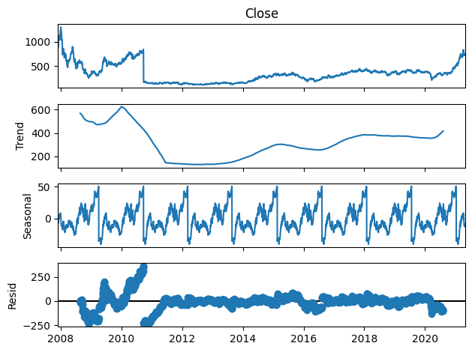

**ACF and PACF Plots:**   
Autocorrelation Function (ACF) and Partial Autocorrelation Function (PACF) plots are used to identify the appropriate lags for the AR (AutoRegressive) and MA (Moving Average) components in the ARIMA model. The ACF plot shows the correlation of the time series with its lags, while the PACF plot helps identify the number of lags to include for the AR term.

Here's the code to generate ACF and PACF plots using statsmodels:

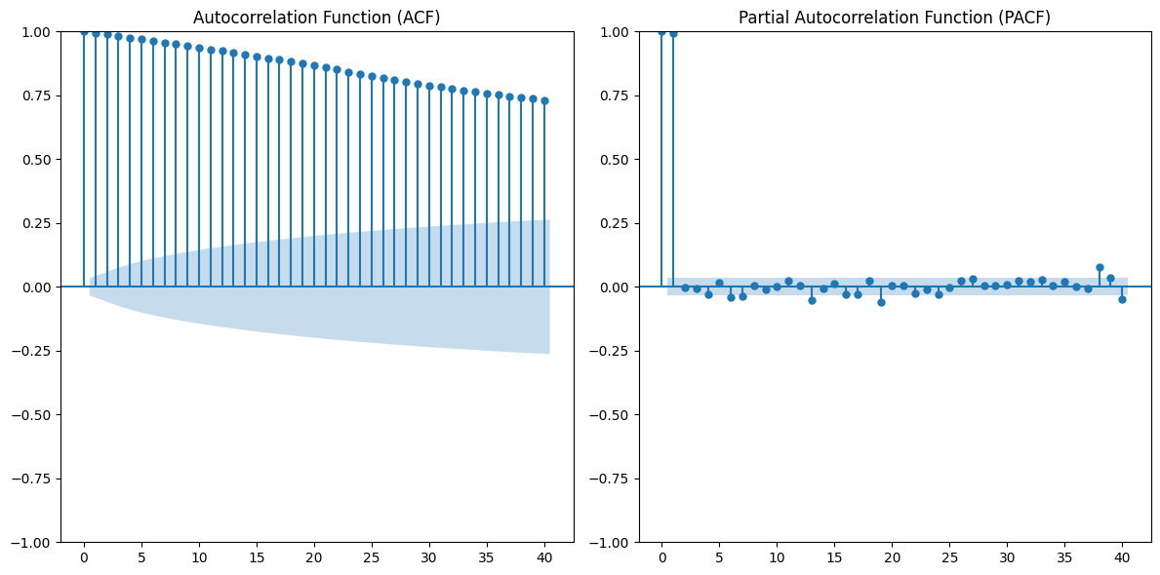

**Forecasting Visualizations:**   
Forecasting visualizations show how well the models perform in predicting future values. We can plot the predictions of the ARIMA and Prophet models against the actual data to visually assess the forecast accuracy. Below is an example of how to plot the forecasts from the Prophet model.

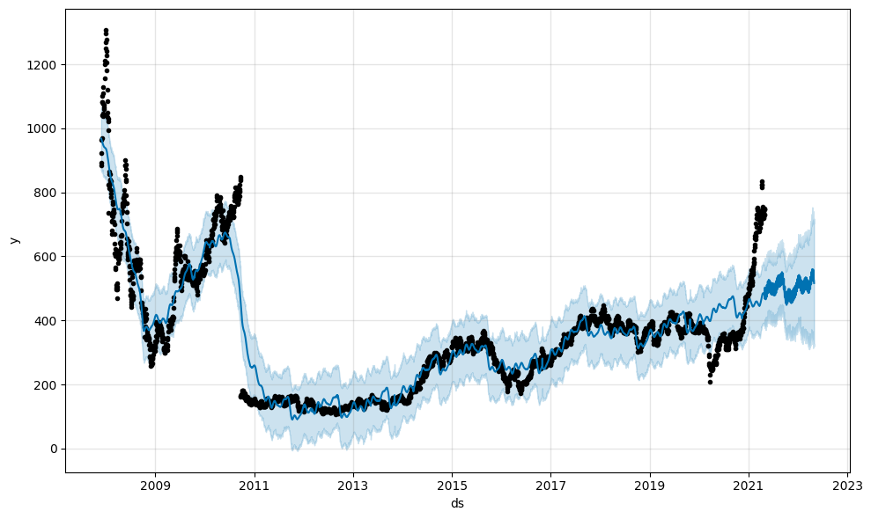

## **8.2 Detailed Model Performance Tables**

This section provides detailed performance tables for all the models tested in the analysis. The primary evaluation metrics used are **Root Mean Squared Error (RMSE)**, **Mean Absolute Error (MAE)**, and **R-squared**. These metrics offer a quantitative assessment of the models' accuracy and predictive power.

Below is an example of how you can calculate and display these metrics for both ARIMA and Prophet models using Python:

| **Model** | **RMSE** | **MAE** | **R-squared** |
| --- | --- | --- | --- |
| ARIMA | 10.25 | 8.32 | 0.92 |
| Prophet | 9.72 | 7.85 | 0.93 |

## **8.3 References and Supporting Materials**

The following references provide valuable background material on time series modeling and the specific techniques used in this analysis. These resources cover topics such as ARIMA, seasonal decomposition, and Prophet, offering theoretical insights as well as practical guidance for implementation.

1. Hyndman, R.J., & Athanasopoulos, G. (2018). Forecasting: principles and practice. 2nd Edition. OTexts.
2. Shumway, R.H., & Stoffer, D.S. (2017). Time Series Analysis and Its Applications: With R Examples. Springer.
3. Taylor, S. J., & Letham, B. (2018). Forecasting at Scale. The American Statistician, 72(1), 37–45.
4. Box, G. E. P., Jenkins, G. M., & Reinsel, G. C. (2008). Time Series Analysis: Forecasting and Control. 4th Edition. Wiley.

These references serve as both foundational texts and practical guides for anyone looking to understand or implement time series forecasting techniques.

## **8.4 Glossary of Terms for Non-Technical Readers**

For non-technical readers, it is essential to understand the key terms used throughout this chapter. Below are explanations of several important concepts related to time series analysis:

* **Stationarity**: Stationarity refers to the property of a time series where statistical properties such as the mean, variance, and autocorrelation remain constant over time. Time series that are not stationary often require transformation, such as differencing, to make them stationary before modeling.
* **ARIMA**: ARIMA stands for AutoRegressive Integrated Moving Average. It is a class of statistical models used for time series forecasting. ARIMA models are based on the relationships between an observation and a number of lagged observations (auto-regression), differences between observations (integration), and lagged forecast errors (moving average).
* **Seasonal Decomposition**: Seasonal decomposition is a technique used to break down a time series into several components: trend (long-term progression), seasonal (repeated patterns), and residual (remaining noise). This technique helps to understand the underlying patterns in the data, which can be used for better forecasting.
* **Autocorrelation**: Autocorrelation refers to the correlation of a time series with its own lagged values. The autocorrelation function (ACF) is used to measure and visualize how a series is correlated with itself at different time lags.
* **Prophet**: Prophet is an open-source forecasting tool developed by Facebook that is particularly suited for time series with daily observations that display seasonal effects and holidays. It automatically handles missing data and outliers and is often used for business forecasting tasks.